Project Management

Assessment ONE

12345 John in wells college

|  |  |  |  |
| --- | --- | --- | --- |
| Name of Student | Daniel Augusto Rodriguez Sanchez | ID | 70254 |

**Assessment 1 – Case Study**

Contents

Instruction: 2

Duration: 2

Case Study: 2

Going Green application, Green IT Project Management 2

Project profile 2

Business situation 4

Your tasks: 4

Task 1: Identify Business Strategy and Gap 4

Task 2: Recommend a feasible solution 5

Task 3: Produce a Project Charter 5

Task 4: Project Document 6

Task 5: Project Closure 9

Helpful web links to complete the assessment: 12

Search Index 13

## Instruction:

This task is to be completed individually. You need to analyse a case scenario and complete all the tasks mentioned after the scenario.

You need to demonstrate your IT project management ability to identify business strategy and gaps. You will also need to suggest a feasible solution to overcome identified gaps and produce a project charter along with a WBS to implement the proposed solution.

### Duration:

Trainer will set the duration of the assessment.

All my working could be checked at: https://danielrs11.github.io/projectmanagement/

## Case Study:

### Going Green application, Green IT Project Management

# Project profile

Going “Green” is a mission of many companies around the globe not just for reasons of environmental responsibility, but also for cutting costs in these extremely tight economic times. Green IT efforts represent a specific focus area within enterprises that hold attention to this trend. Green IT leverages information technology to streamline operations, cut costly waste, and reduce the impact on the environment. IT typically consumes only about 10% of an organization’s energy costs, but the net effect of a Green IT project is to go beyond just energy saving. To tackle the other 90%, a Green IT project extends into a variety of other departments, and to execute such an endeavour requires an effective project management function in order to identify and prioritize goals. A Green IT transformation can be a complex process.

Vital Statistics:

* Number of project tasks - 12
* Project duration - 16 months
* Project budget - $1,200,000
* Number of users - 50

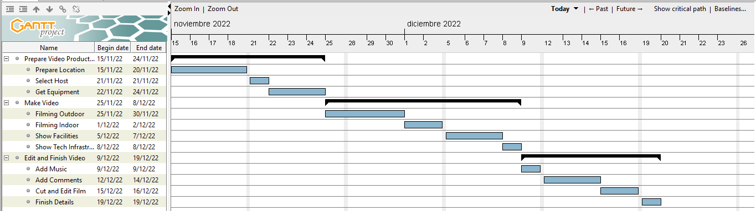

### Business situation

In order to promote the school, it was proposed to make a video in which all the benefits of the institution are shown, in addition to its facilities and its technological capacity that allows it to provide quality education to its students. For this, it is necessary to make recordings of both interior and exterior installations, choose the right person to present them, and do the final editing of the video.

## Your tasks:

### Task 1: Identify Business Strategy and Gap

Document the business’s strategies of “Green IT” and also summarise the components required changes for the participating organisation to implement “Green IT Project”. (Min. 300 words)

Business strategy is a planning function of any organisation. Business strategy incorporates having a strategic plan.

**Analyse Strategy**

The strategic plan of an organisation sets out the goals a business hopes to achieve within a specified period of time. It also helps the organisation understand the environment within which they operate and the market forces that affect them.

An analysis of the current strategic plan enables you to understand the goals of your organisation. However, in order to analyse the strategic plan, you first need to understand the structure and purpose of a strategic plan. This topic describes the elements that make up a strategic plan.

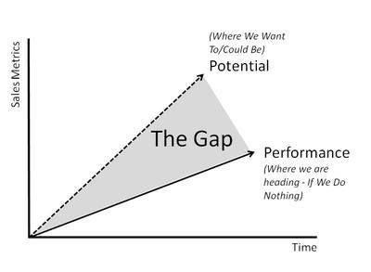The green project we need defined every requirement. The gap which is between your plan and reality always need your notice. So you need do your best to investigate your Green Project.

### Task 2: Recommend a feasible solution

Assume “Wells International College” is thinking of going “Green” and asked for your assistance in this project. Research different project management applications on the Internet to compare with the Green IT project management application and recommend a feasible solution with proper reasons for Windsor. (Min. 300 words)

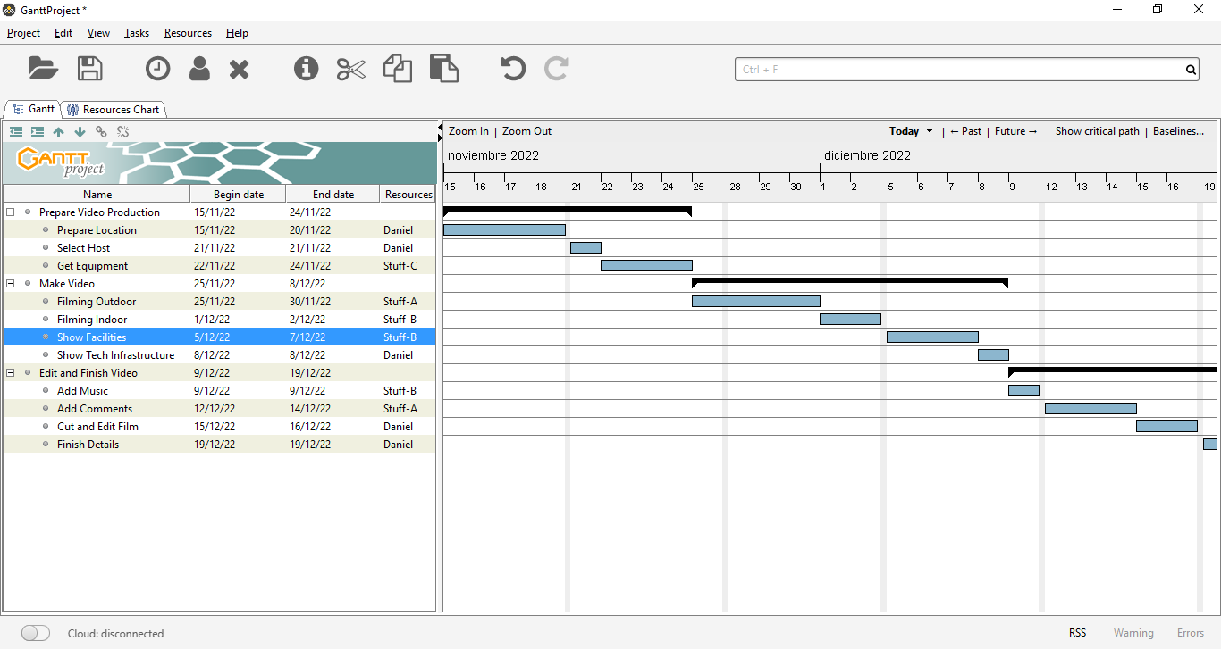

There are multiple applications that allow you to properly manage a technological project in any work environment. We can find both local and cloud software that adapt to the needs and size of each project. Some of the most popular apps are: Monday, Asana, Wrike, Basecamp, ClickUp and of course Microsoft Project.

In the case of this project, I believe that given its size, it is not necessary to invest in a robust application, but instead you can take advantage of free resources such as the Gantt Project software. Its versatility and ability to organize the project helps to easily manage time.

GanttProject is a cross-platform desktop application for project scheduling and management, very similar to Microsoft Project. It runs on Windows, Linux and MacOSX, it is free and its code is open source. Based on the Java language and licensed under the GPL, it is a software project that arose at the University of Marne-la-Vallée, in France.

One of its main features is the creation of Gantt charts. The graphic design allows visualizing the breakdown of scheduled tasks or activities, the events or milestones in the development of the project, as well as the hierarchical relationships and interdependencies between tasks. GanttProject shows, in the left section, a bar to add activities associated with a specific duration and a specific workforce. Once they have been incorporated, associations can be established between them, according to different correlations: start-start, end-start, or other similar ones. Once the tasks, events and their temporal relationship have been defined, the project planning calendar will appear on the right side of the screen, including dates and resources, as well as other additional information. Another interesting functionality of the GanttProject application is that it automatically generates an associated PERT chart and a chart of required human resources assigned to each task. These additional graphic representations provide those responsible with a clearer vision regarding the timely progression in the development of the project, and the adequacy of the personnel involved in it.

### Task 3: Produce a Project Charter

Please view my project charter (here only show part):

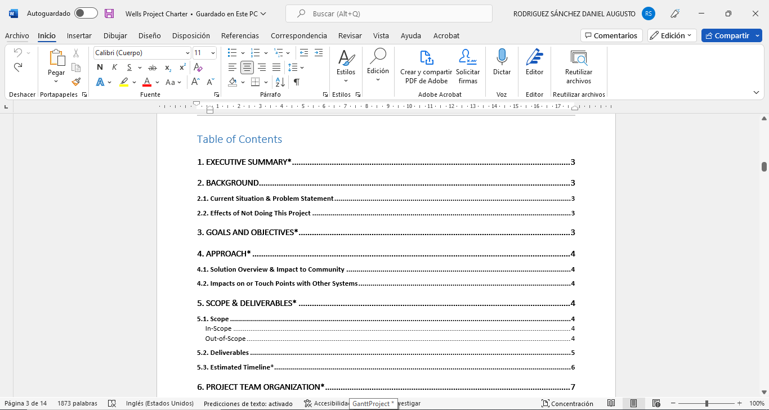

### Task 4: Project Document

Please check my site: https://danielrs11.github.io/projectmanagement/

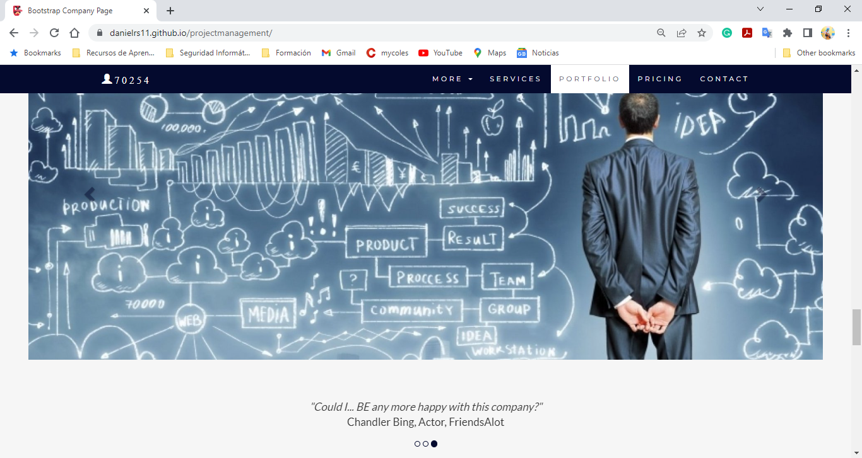

Refer to your current project, you have been asked to develop a project plan for WIC. Project plan outline as following:

In my Green project, I design following topics: Table of Contents

1. EXECUTIVE SUMMARY

2. BACKGROUND

2.1. Current Situation & Problem Statement

2.2. Effects of Not Doing This Project

3. GOALS AND OBJECTIVES

4. APPROACH

4.1. Solution Overview & Impact to Community

4.2. Impacts on or Touch Points with Other Systems

5. SCOPE & DELIVERABLES

5.1. Scope

In-Scope

Out-of-Scope

5.2. Deliverables

5.3. Estimated Timeline

6. PROJECT TEAM ORGANIZATION

6.1. Roles & Responsibilities

6.2. Stakeholders

7. FINANCIALS

7.1. Estimated Project Costs

7.2. Estimated Ongoing Support Costs

7.3. Funding Source

7.4. Flexibility Matrix & Contingencies

8. PROJECT RISKS & ASSUMPTIONS

Assumptions and Constraints

9. APPENDIX

### Task 5: Project Closure

Prepare project closure document template as following:

* Project Sign-off document

When project sign off, it means your project finished. So you need make one clear sheet to tell everyone about your project. It will include:

* project start date
* project manager
* project finish date
* if something is going wrong
* ...

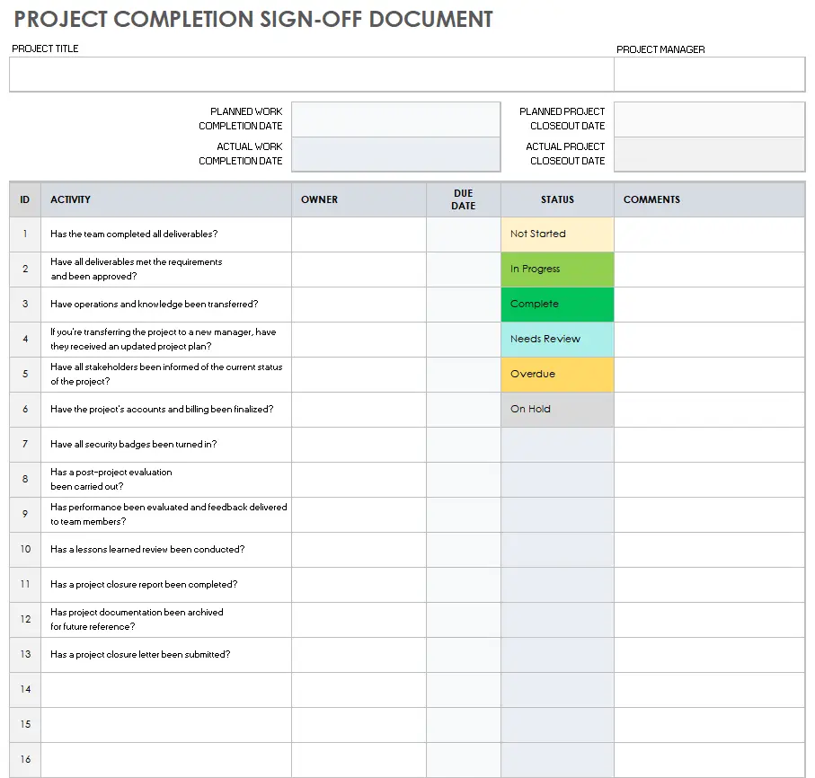

* Project evaluation document

You need show about your project, good or not enough. Summary all about your project

It may include:

* Budget evaluation
* Quality evaluation
* Benefit evaluation
* Etc...

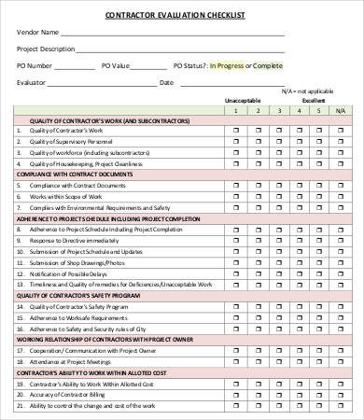

* Lesson learned template
* What we have learn through this project
* What we need to do if next project start
* What we learn some lesson. We could not make same mistake again.
* Etc.

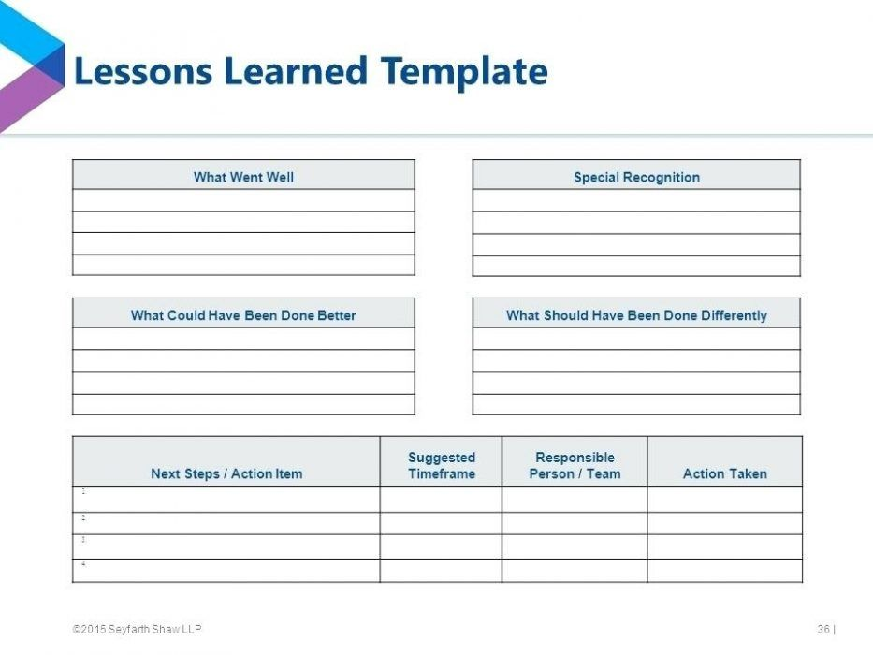

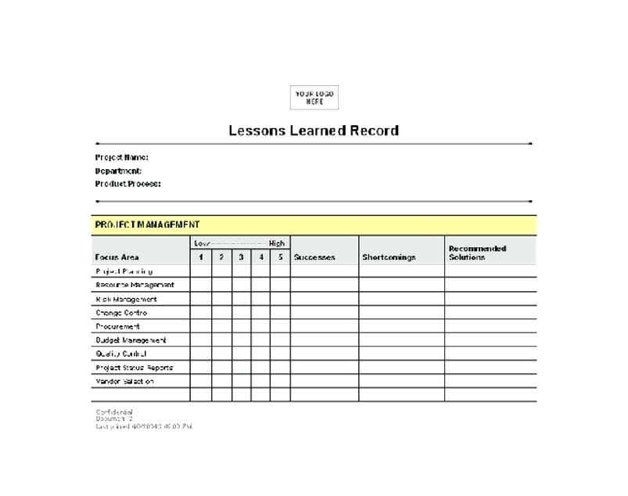

## Helpful web links to complete the assessment:

## Search Index

B

Benefit evaluation 10

Budget evaluation 10

F

feasible solution 1, 4

P

project sign off 9

Q

Quality evaluation 10

S

same mistake 10

scenario 1

specific focus 2